**Aim:**

The objective of this project is to classify a Fruits image dataset using Convolutional Neural Network into the following classes: (0) Apples, (1) Bananas, (2) Mixed, (3) Oranges.

**A Brief description of changes made in our CNN models**

1. Performed different stackings of Convolutional (Conv2D) layers with varying number of filters and filter sizes to experiment with the impact different degrees of feature extraction has on accuracy.
2. Performed different stackings of Max Pooling layers with varying window sizes to experiment with the impact varying degrees of dimensionality reduction on feature maps has on accuracy.
3. Added different stackings Dropout layers with different dropout rates to experiment with the impact varying number of Dropout layers and fractions of neurons has on accuracy.
4. Performed runs with varying numbers of epochs to experiment the impact it has on accuracy.

**Evaluation of our CNN models**

|  |  |  |  |  |
| --- | --- | --- | --- | --- |
| Indicators | CNN Model 1 | CNN Model 2 | CNN Model 3 | CNN Model 4 |
| Model Results | | | | |
| Training Loss | 0.0627 | 0.1767 | 0.0241 | 0.0623 |
| Training Accuracy | 0.9917 | 0.9417 | 1.0000 | 0.9667 |
| Validation Loss | 0.6363 | 0.4992 | 0.7232 | 0.8913 |
| Validation Accuracy | 0.8500 | 0.9000 | 0.8833 | 0.9000 |
| Training Time | 8.3695s | 20.2121s | 9.8789s | 20.8939s |
| Prediction Time | 0.0375s | 0.0409s | 0.0403s | 0.0459s |

**Plot of loss and accuracy of our best model (CNN model 2)**

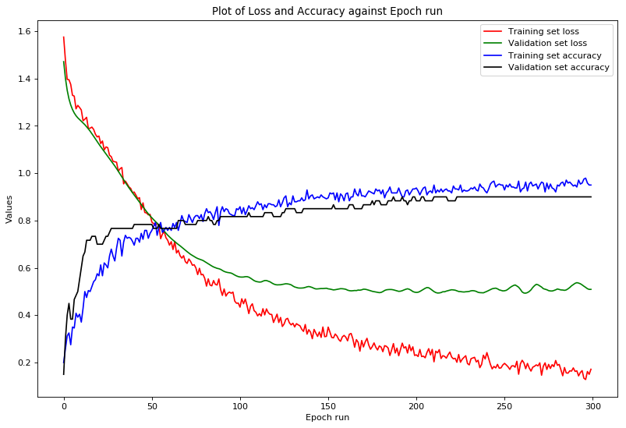

**Best/final accuracy of our image classifier on the test data**

The most accurate models are CNN Model 2 and Model 4 as they both have a prediction accuracy of 90%. However, CNN Model 2 is marginally faster to train than Model 4.

**A reflection of lessons learnt in building our network**

***On Data Balancing:***

|  |  |  |  |  |
| --- | --- | --- | --- | --- |
| Volume of input data/ images | | | | |
| Data Sets | Apples | Banana | Mixed Fruits | Oranges |
| Train | 76 | 76 | 20 | 76 |
| Test | 19 | 18 | 5 | 18 |

Images of mixed fruits were inaccurately predicted in all 4 CNN models consistently, whilst apples, oranges and bananas had more accurate predictions across all models. This is due to the small proportion of mixed fruit images in the training dataset. Since the model was trained only on 20 images of mixed fruits, it is not able to predict images of mixed fruits as accurately compared to the other classes.

***On Model Architecture and Accuracy:***

CNN Model 2 consistently produces a higher accuracy than the other CNN models. It has a simple structure which utilises 1 Conv2D layer of 32 filters of size 3 pixels by 3 pixels, a pooling layer with pooling window of size 6x6, 1 dropout layer, 1 flatten layer and lastly, 1 dense layer with a softmax activation function.

A complex model architecture does not necessarily imply a greater accuracy. CNN Model 2 and 4 have similar accuracies despite Model 4 having a more complex architecture.

***On the size of the Input Image:***

We used 2 different input image sizes to observe the impact that input image sizes have on accuracy and duration.

We initially used an input image size of 34px by 34px. Following which, we experimented with an input image size of 128px by 128px. However, this results in a substantially longer training time without any significant improvements in accuracy.

Based on our experiments, we found that having an input image size of 34px by 34px is better. Not only was the model training time shorter, but accuracy was also relatively high at 90%.

In conclusion, we realise that having a larger input image size does not necessarily lead to greater accuracy.

**Appendix A: Image of banana_10.jpg after data pre-processing (34px by 34px)**

